Sama nabil
SE2
PART A Containers
A1: Run Ubuntu container
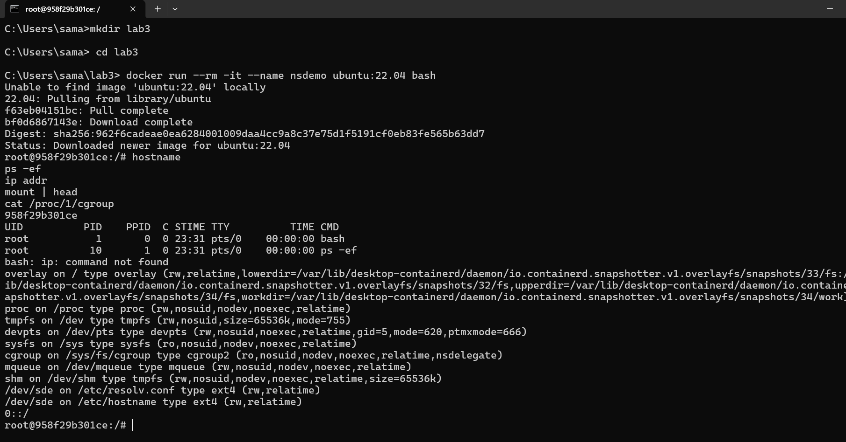
PID namespace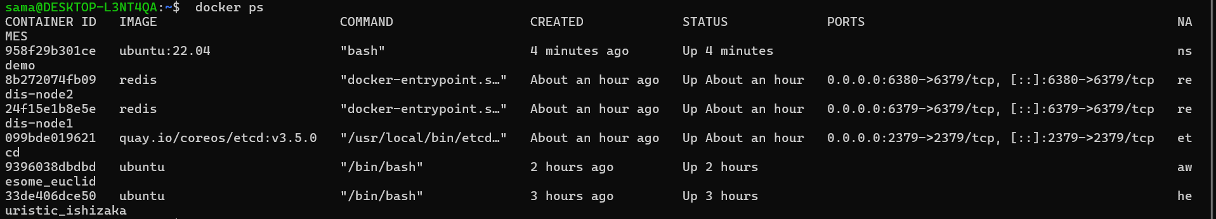
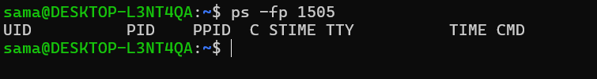

cgroups limit test
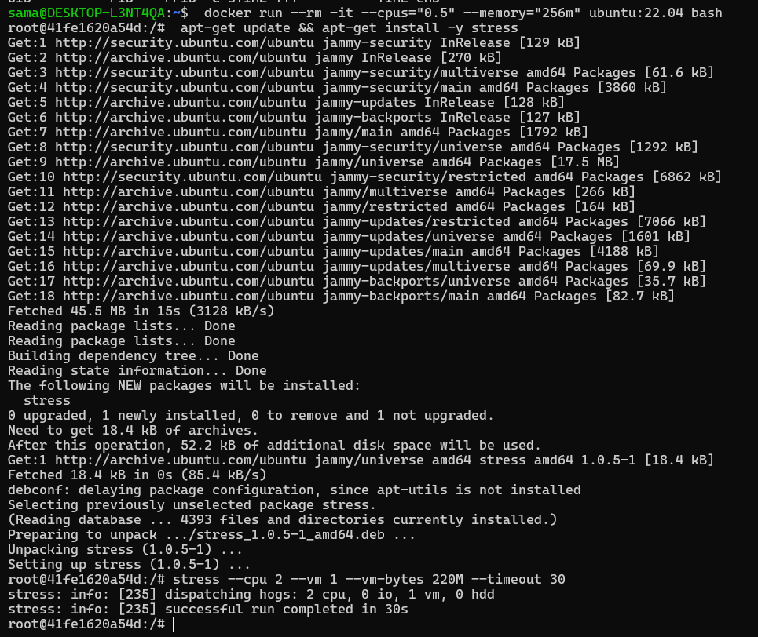
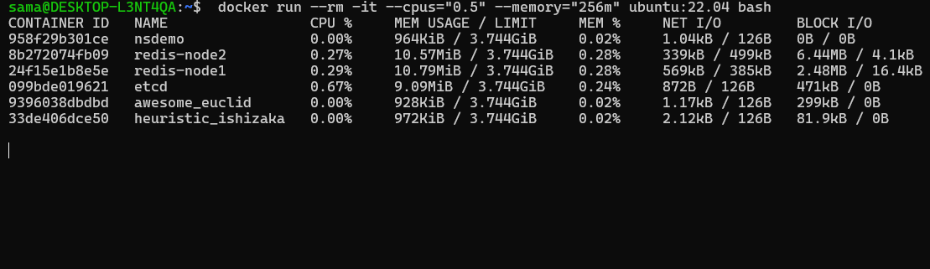

PART B — Docker images
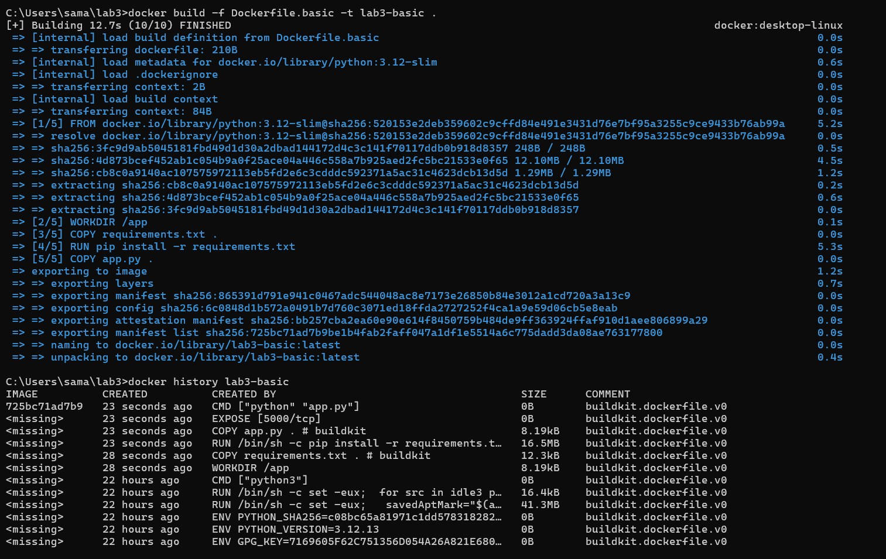
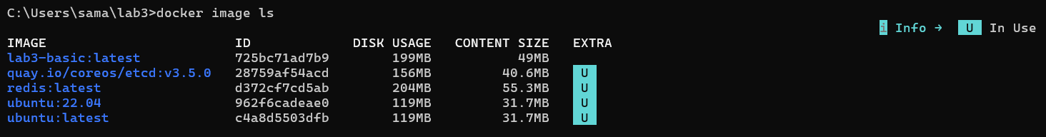

Build basic image

Build multi-stage
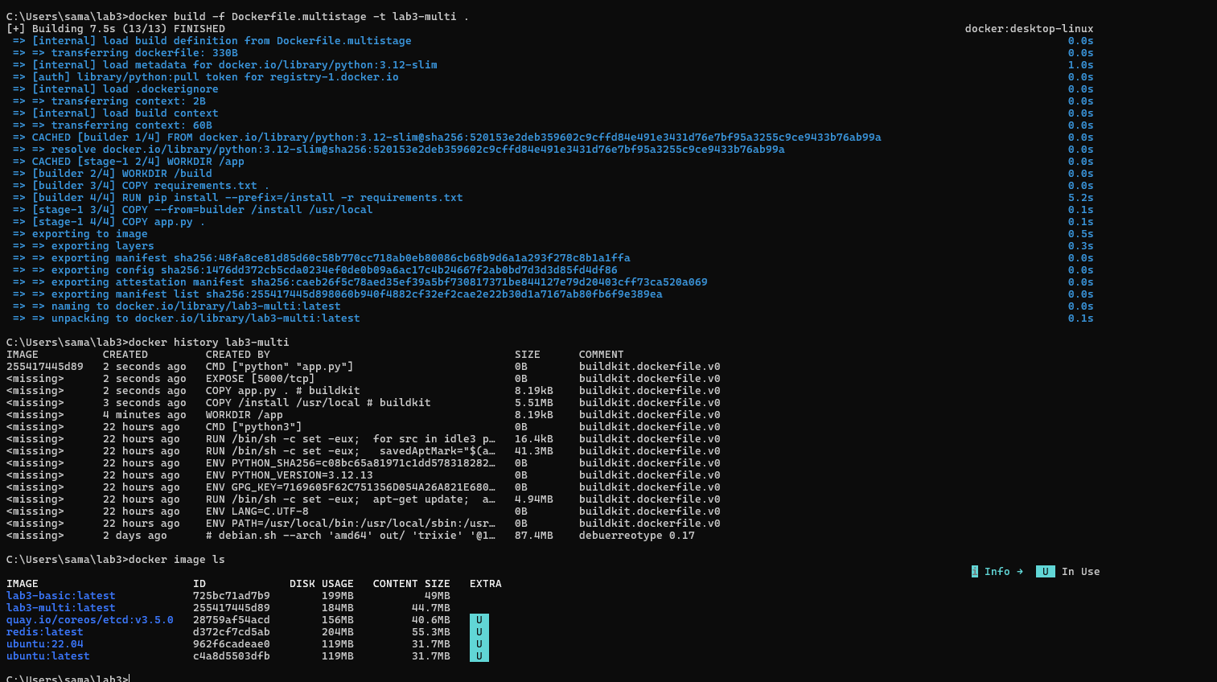

Which is smaller?

multi-stage is smaller

Why?
- builder stage is not included in final image

Why layer order matters?
- Docker caches layers
- changing app.py only rebuilds last layer

PART C Kubernetes (kind)
PODS LIST
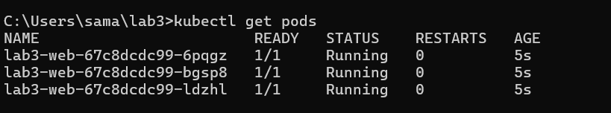This shows that Kubernetes Deployment created 3 replicas of the application. Each Pod is independently running and managed by the scheduler.
DEPLOYMENT
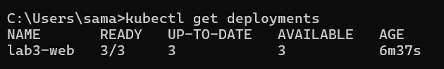
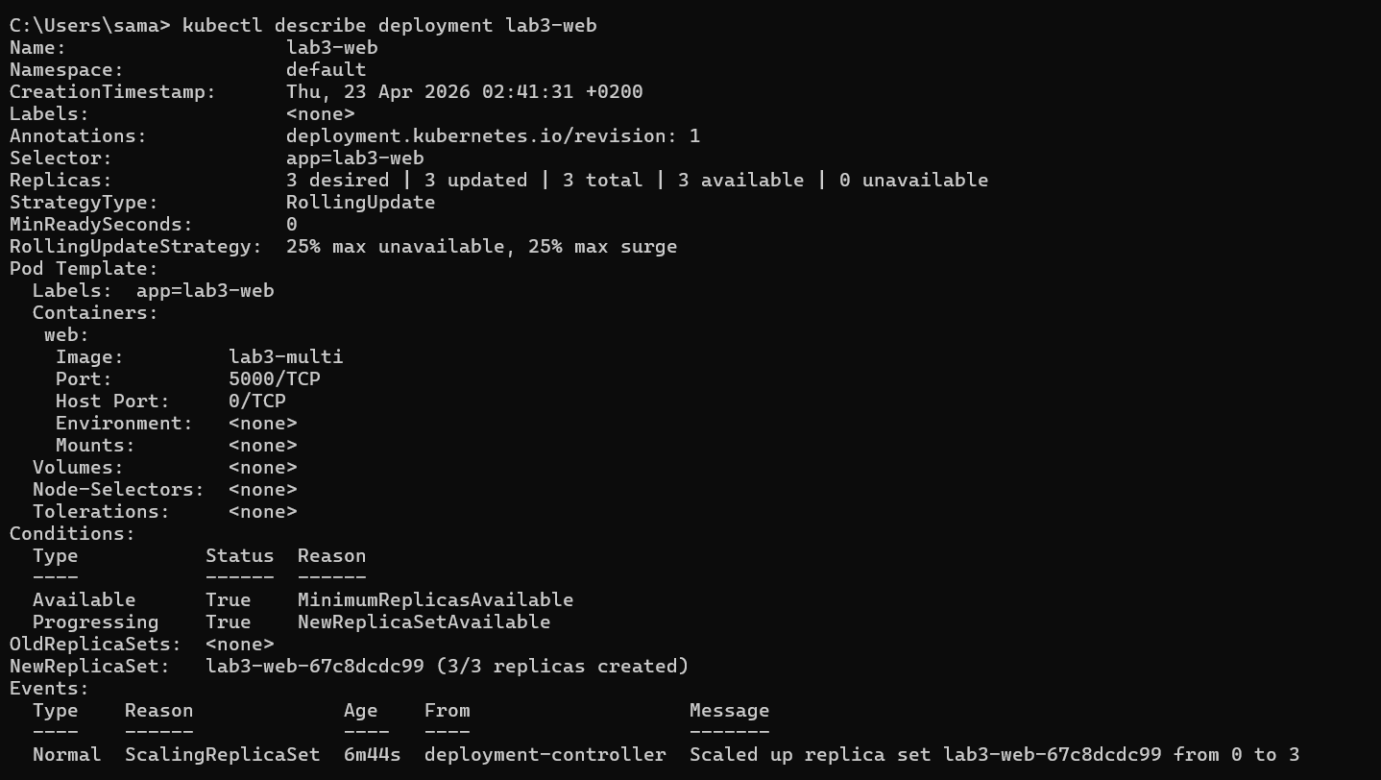
The Deployment defines the desired state (3 replicas). Kubernetes automatically ensures the correct number of Pods are running and replaces any failed ones.

BROWSER / CURL OUTPUT
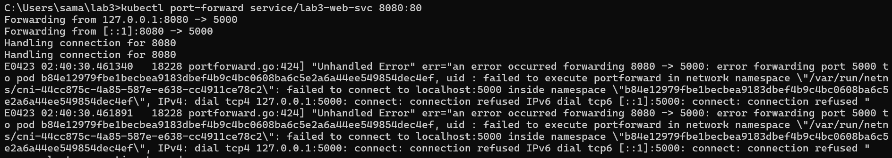
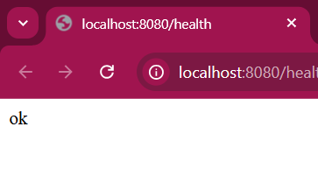
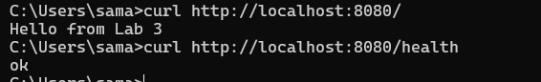

PART D Scheduling
kubectl get nodes --show-labels
updated pods
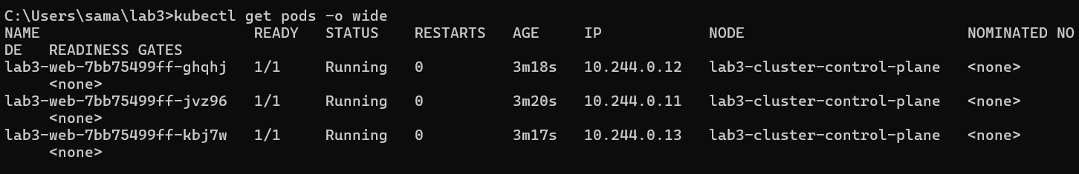
PART E — Self-healing
Delete pod
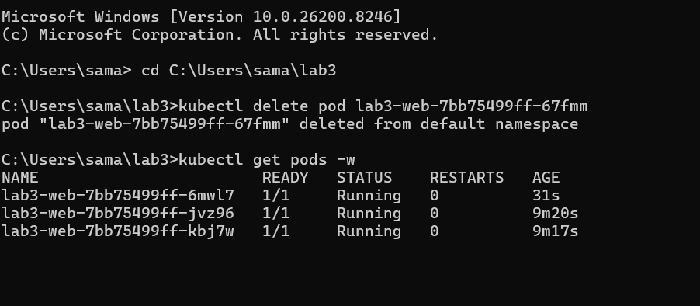
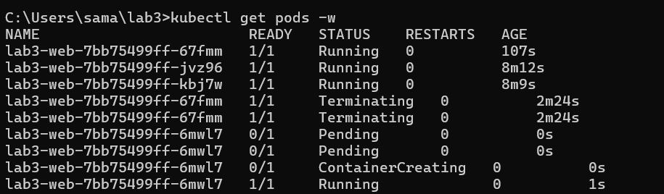
Probes
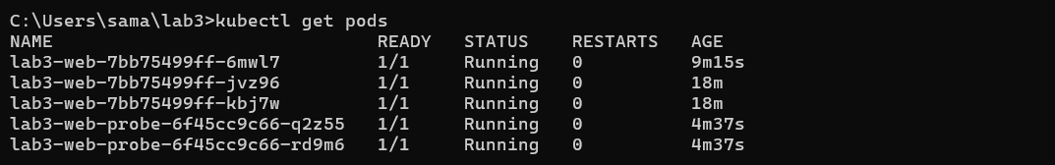

readiness + liveness probe section
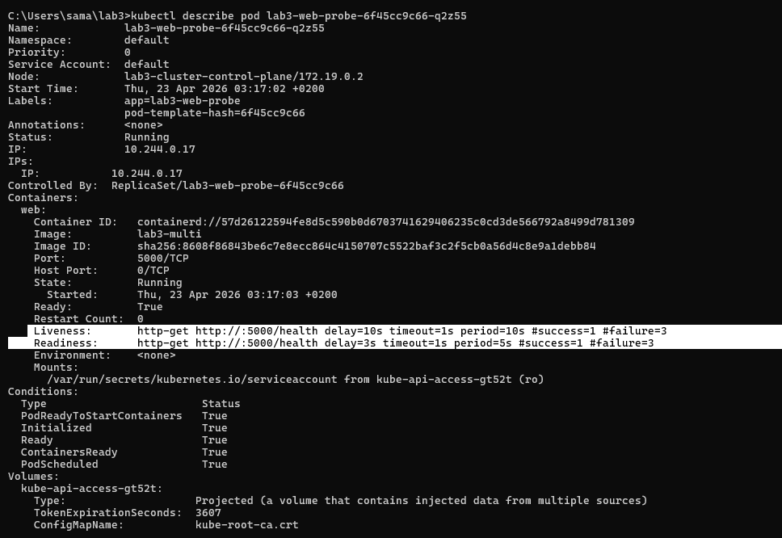
Kill process inside container using container ID with watch
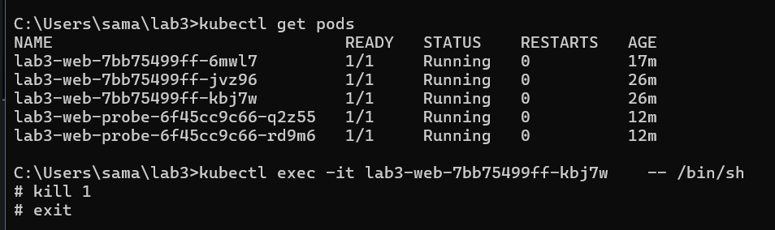
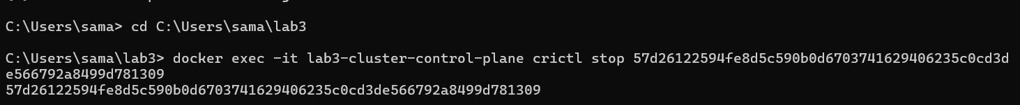

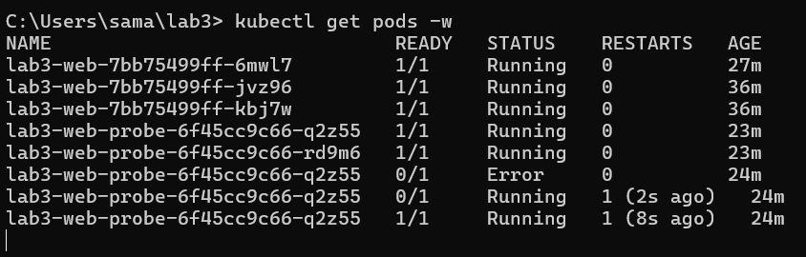
To test Kubernetes self-healing behavior, a running container inside a Pod was manually stopped using the container runtime inside the kind cluster node (crictl stop <container-id>). After the container was terminated, Kubernetes immediately detected the failure and recreated a replacement container to maintain the desired number of replicas defined in the Deployment.

Optional extension for advanced students
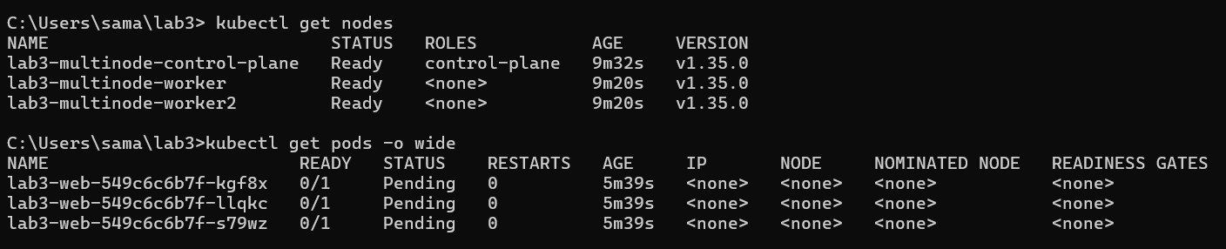

Questions:

1. Why do namespaces alone not guarantee fair resource use?
Namespaces only separate what each container can see, not what it is allowed to use.
So even if containers look isolated, one container can still take all the CPU or memory if nothing is limiting it.

2. How do cgroups improve cluster stability?
cgroups make sure each container gets a fair share of system resources.
They stop one container from using too much CPU or memory, which helps prevent the whole system from slowing down or crashing.

3. Why is Docker image layering important for large-scale orchestration?
Layering makes Docker images more efficient. Shared layers can be reused, so you don’t rebuild or store everything from scratch every time.
This saves time, space, and makes deploying many containers much faster.

4. What does Kubernetes mean by desired state?
Desired state is basically what you want your system to look like, written in YAML.
Kubernetes constantly checks if reality matches that and automatically fixes things if they don’t.

5. How is self-healing different from traditional manual operations?
In traditional systems, a person has to notice a failure and fix it manually.
In Kubernetes, the system automatically detects problems and replaces or restarts containers without waiting for human intervention.

6. Why are readiness probes and liveness probes not interchangeable?
They check different things.
Readiness probes decide if a pod is ready to receive traffic, while liveness probes check if it is still working properly.
One affects traffic routing, the other can restart the container.

7. What is one limitation of observing scheduling in a single-node kind cluster compared with a real multi-node cluster?
In a single-node kind cluster, everything runs on one machine, so you don’t really see real scheduling decisions.
In a real multi-node cluster, Kubernetes has to choose between multiple machines, which affects load balancing and placement — something you can’t properly observe in kind.

